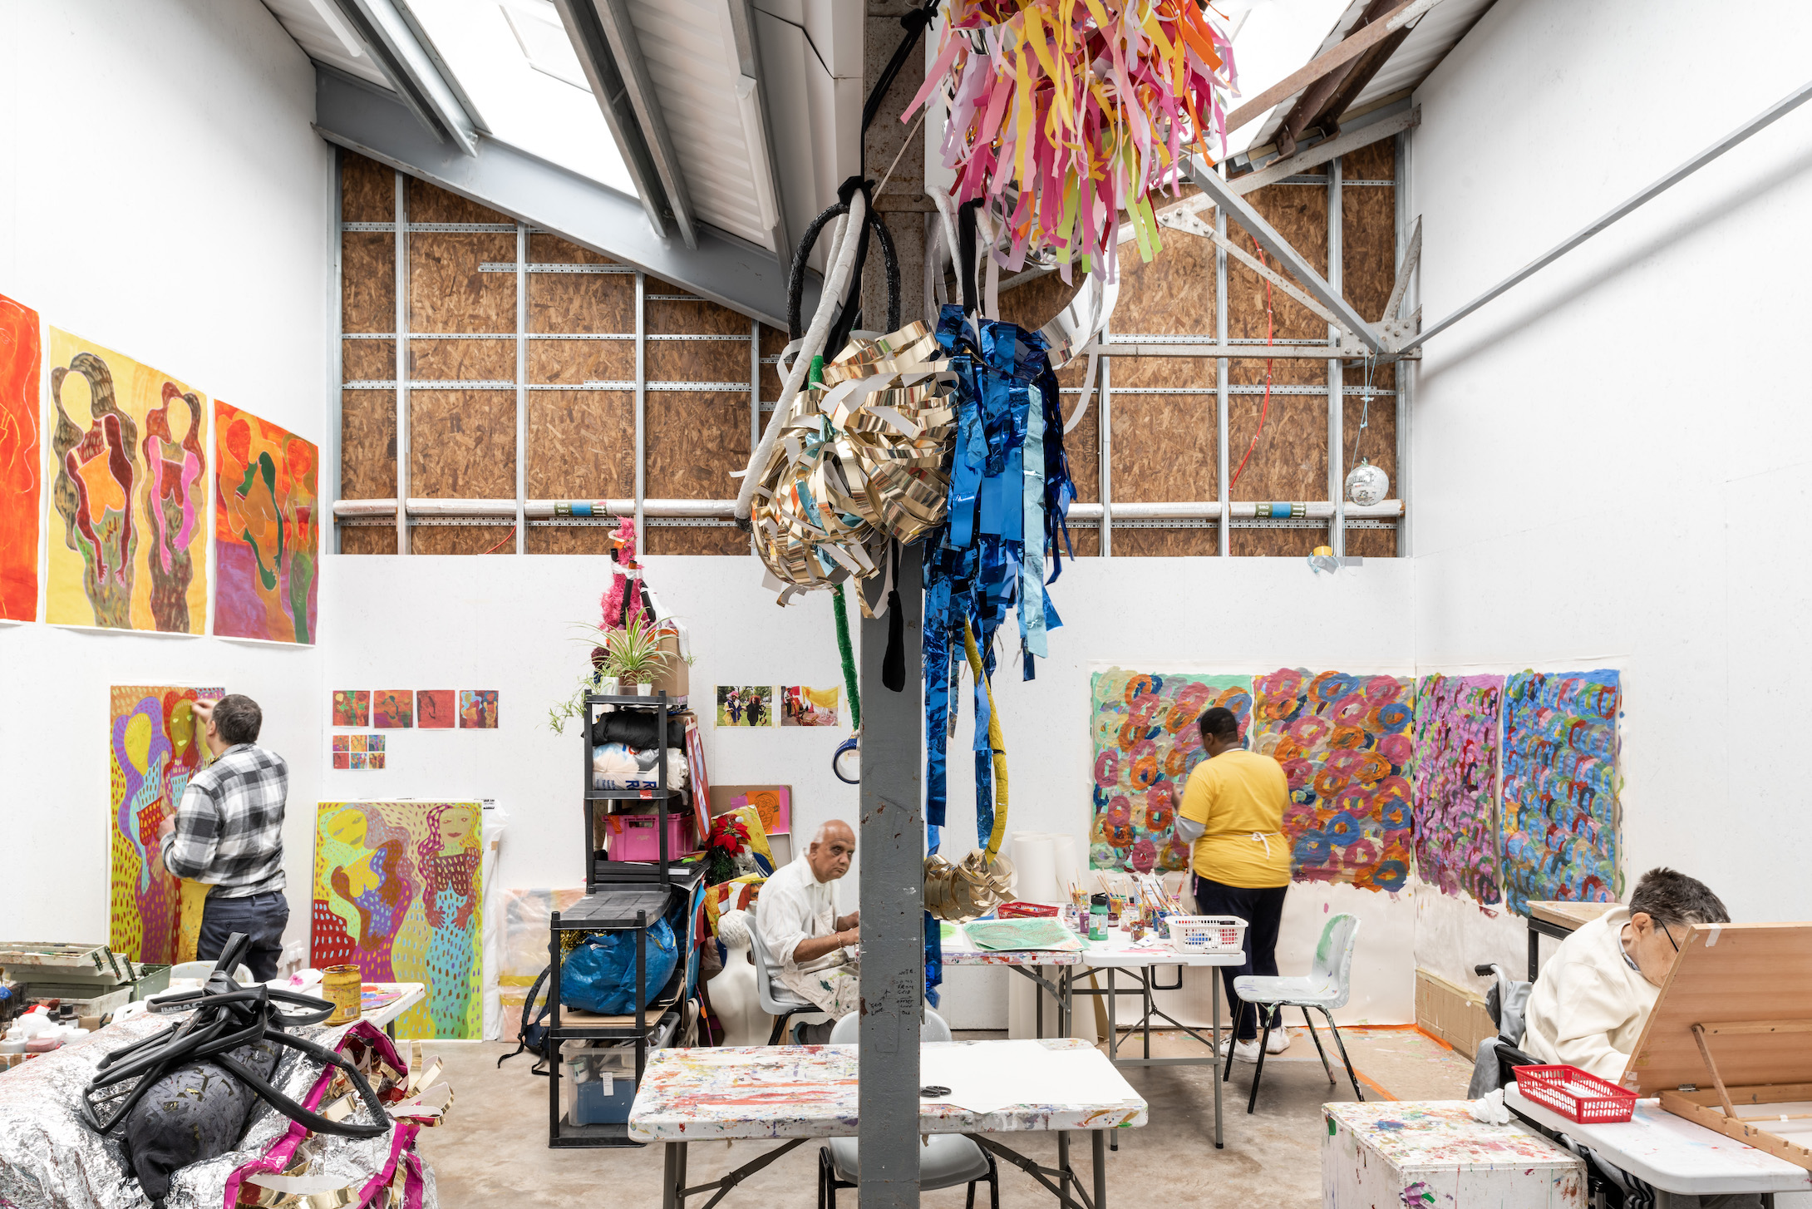

ActionSpace studio at Studio Voltaire. Credit FRENCH+TYE.

Launched in the 1960’s, ActionSpace supports learning disabled artists by providing a studio space, art materials and exhibition opportunities. Weekly Studio Projects provide a supportive and safe environment in which our artists can explore and develop their creative talents, with guidance from a professional artist facilitator. Our artists gain a sense of their own potential – as do those around them. Through developing a creative medium for self-expression, their self-esteem increases and their sense of isolation is reduced

Today’s date: ___/___/_____

Personal details:

Full name:

Telephone number: ______________________________________________________________________

Email:

Address

____________________________________________________________________________________________________________________________________________

Post code

Date of Birth: ___/___/_____

Health and Access Needs:

Do you have a learning disability? Yes/No

If yes, please describe your learning disability:

____________________________________________________________________________________________________________________________________________

Do you have a physical disability? Yes/No

If yes, please describe your physical needs:

____________________________________________________________________________________________________________________________________________

Do you have any medical conditions? Yes/No

If yes, please write below:

____________________________________________________________________________________________________________________________________________

Are you making art at the moment? Or have you taken part in art sessions before?

If yes, where?

____________________________________________________________________________________________________________________________________________

What type of art do you like to make? ____________________________________________________________________________________________________________________________________________

What are your interests? Or what things do you like? ____________________________________________________________________________________________________________________________________________

Is there anything you do not like? or anything that makes you feel upset?______________________________________________________________________

______________________________________________________________________

Contact Information:

Emergency Contact:

Name: _____________________________________________________________________

Relationship to You: ______________________________________________________________________

Telephone Number:

______________________________________________________________________

Email: ______________________________________________________________________

Home contact (e.g. a house/care manager for those not living with family):

Name: _____________________________________________________________________

Job role/relationship to you: _____________________________________________________________________

Telephone Number: _____________________________________________________________________

Email: ______________________________________________________________________

How would you describe your ethnic background? (please tick one)

|  |  |
| --- | --- |
| Asian/Asian British: Indian |  |
| Asian/Asian British: Pakistani |  |
| Asian/Asian British: Bangladeshi |  |
| Asian/Asian British: Chinese |  |
| Asian/Asian British: Any other Asian background |  |
| Black / African / Caribbean / Black British: Black African |  |
| Black / African / Caribbean / Black British: Black Caribbean |  |
| Black / African / Caribbean / Black British: Any other Black /African / Caribbean background |  |
| Mixed / Multiple ethnic groups: White & Black Caribbean |  |
| Mixed / Multiple ethnic groups White & Black African |  |
| Mixed / Multiple ethnic groups: White & Asian |  |
| Mixed / Multiple ethnic groups: Any other Mixed / Multiple ethnic background |  |
| Other Ethnic Groups: Arab |  |
| Other Ethnic Groups: Latin American |  |
| Other Ethnic Groups: Any other ethnic group |  |
| White: English / Welsh / Scottish / Northern Irish / British |  |
| White: Irish |  |
| White: Gypsy or Irish Traveller |  |
| White: Any other White background |  |
| Prefer not to say |  |

Thank you for filling in this form. Please send it back to:

Maisie Rennie-Carter

ActionSpace

Cockpit Arts

Cockpit Yard

Northington Street

London

WC1N 2NP

Or return it by email to [maisie@actionspace.org](mailto:maisie@actionspace.org)

If you need any more information or have any questions about this or any other ActionSpace project, please call Maisie on 020 7209 4289 or email info@actionspace.org

For office use:

Which group/s

Trial sessions

Start date

Payment method